**2019 Year 11 Physics**

**Task 10: Test 5 – Motion**

Name: \_\_\_\_\_\_\_\_\_\_\_\_\_\_\_\_\_

\_\_\_\_\_\_ / 47

(3 marks)

From your home, you drive 10.0 km East to pick up one friend then 27.00 km West to pick up another person.

## What distance did you travel from home? (1 marks)

## Using a diagram, show what your displacement is from home. (2 marks)

(3 marks)

The end of recess bell has gone and Stephen Hawking (RIP) now has 1 minute 50 seconds to get to his Physics class. He can motor at a constant 5.30 ms-1 and he needs to travel a displacement of 4.00 x 102 m West. Will he make it in time?

(2 marks)

Bodhi the dog is walking through the bush at 1.44 m s-1 when he sees a cow eating in front of him. If he accelerates at 3.60 m s-2 for 3.75 s to reach the cow, what was his velocity when he reached the cow?

(6 marks)

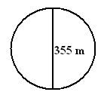Albert and Isaac are exercising together in a large park. Within the park is a circular path with another path which is 355 m long that acts as a diameter to the circle. The diagram illustrates this situation.

## Albert and Isaac are running across the diameter 355 m from one side of the circular path to the other at a speed of 6.00 m s-1. How long will it take them to run this path?

## j0343333 (1 mark)

## Albert stops to rest at the other side, but Isaac continues to run at a speed of 6.00 m s-1 on the circular part of the path. During this time, is Isaac accelerating? Fully Explain.

## (3 marks)

\_\_\_\_\_\_\_\_\_\_\_\_\_\_\_\_\_\_\_\_\_\_\_\_\_\_\_\_\_\_\_\_\_\_\_\_\_\_\_\_\_\_\_\_\_\_\_\_\_\_\_\_\_\_\_\_\_\_\_\_\_\_\_\_\_\_\_\_\_\_\_\_\_\_\_\_\_\_\_\_\_\_\_\_\_\_\_\_\_\_\_\_\_\_\_\_\_\_\_\_\_\_\_\_\_\_\_\_\_\_\_\_\_\_\_\_\_\_\_\_\_\_\_\_\_\_\_\_\_\_\_\_\_\_\_\_\_\_\_\_\_\_\_\_\_\_\_\_\_\_\_\_\_\_\_\_\_\_\_\_\_\_\_\_\_\_\_\_\_\_\_\_\_\_\_\_\_\_\_\_\_\_\_\_\_\_\_\_\_\_\_\_\_\_\_\_\_\_\_\_\_\_\_\_\_\_\_\_\_\_\_\_\_\_\_\_\_\_\_\_\_\_\_\_\_\_\_\_\_\_\_\_\_\_\_\_\_\_\_\_\_\_\_\_\_\_\_\_\_\_\_\_\_\_\_\_\_\_\_\_\_\_\_\_\_\_\_\_\_\_\_\_\_\_\_\_\_\_\_\_\_\_\_\_\_\_\_\_\_\_\_\_\_\_\_\_\_\_\_\_\_\_\_\_\_\_\_\_\_\_\_\_\_\_\_\_\_\_\_\_\_\_\_\_\_\_\_\_\_\_\_\_\_\_\_\_\_\_\_\_\_\_\_\_\_\_\_\_\_\_\_\_\_\_\_\_\_\_\_\_\_\_\_\_\_\_\_\_\_\_\_\_\_\_\_\_\_\_\_\_\_\_\_\_\_\_\_\_\_\_\_\_\_\_\_\_\_\_\_\_\_\_\_\_\_\_\_\_\_\_\_\_\_\_\_\_\_\_\_\_\_\_\_\_\_\_\_\_\_\_\_\_\_\_\_\_\_\_\_\_\_\_\_\_\_\_\_\_\_\_\_\_\_\_\_\_\_\_\_\_\_\_\_\_\_\_\_\_\_\_\_\_\_\_\_\_\_\_\_\_\_\_\_\_\_\_\_\_\_\_\_\_\_\_\_\_\_\_\_\_\_\_\_\_\_\_\_\_\_\_\_\_\_\_\_\_\_\_\_\_\_\_\_\_\_

## Isaac returns to Albert and the pair now run back down the diameter path firstly starting slowly (Isaac is tired) at 2.80 m s-1 but, being competitive, accelerates uniformly to a final velocity of 8.25 m s-1 at the end of the 355 m.

## What was their acceleration? (2 marks)

(3 marks)

A child is playing with Marvin the toy robot, which is travelling at 2.00 m s-1. The child increased the velocity to 5.00 m s-1 in 0.500 s.

How far did the toy travel in this time?

(4 marks)

Galileo is late for work again and is travelling at 1.00 x 102 km h-1 (speed limit 60.0 km h-1) when he sees a car coming in the opposite direction flashing its lights. Assuming that there is a speed gun ahead he starts to slow down (assume his reaction time before he started to brake was 1.65 s). He is decelerating at 4.80 m s-2 when, having very sharp eyes, he sees the speed gun. If he travelled 88.0 m from the time that he saw the car lights flash to the time he is registered on the speed gun, will he be booked?

(4 marks)

A squash player hits the ball at a speed of 35.0 m s-1 at an angle of 30° to the side wall of the court. The ball rebounds at 120° to the original direction at a speed of 27.5 m s-1.

What is the change in velocity?

Hint: use scale diagram.

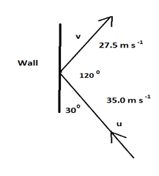

(3 marks)

Sir William Lawrence Bragg is sitting 13.2 m up in the branches of a tree throwing water bombs on people walking underneath. When his Dad, Sir William Henry Bragg (whose head is 1.20 m above the ground) is walking under the tree young Willy throws a water bomb down at his head with an initial velocity of 3.40 m s-1.

How long does young Willy have to hide in the branches, once he has thrown the bomb, so that his Dad can’t see him?

(5 marks)

AN03622_The Golden Dragon is one of the best fliers of all dragons. Below is the graph of one particular dragon as he and his rider take a short trip from one dragon lair to another.



## Calculate the acceleration (in m s-2) of the dragon between 20.0 and 24.0 minutes.

## (2 marks)

## Calculate the displacement of the dragon from the graph above. (3 marks)

(5 marks)

During a basketball practice session, a player shoots a basketball up to the rim above. The ball is 1.80 m above the ground when it is released with an initial velocity of 3.40 m s-1 directly upwards. The shot misses the rim and the ball hits the court before being picked up by another player.

How long was the ball in the air?

A (9 marks)

A keen bushwalker went for an extended hike as shown by the following graph.

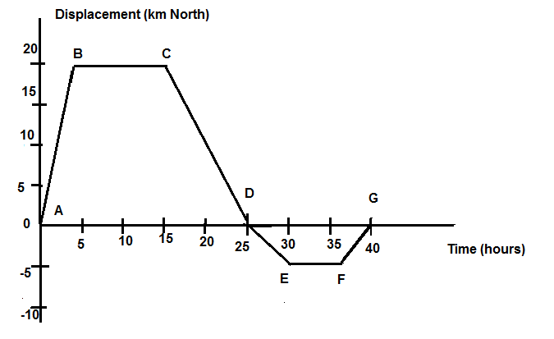

Use the graph to determine the following information:

## How far did the hiker walk? (1 mark)

## Calculate the velocity (km h-1) in the following segments:

## (i) AB (1 mark)

## (ii) EF (1 mark)

## (iii) AG (1 mark)

## (iv) DE (1 mark)

## Draw a graph of velocity versus time. (3 marks)

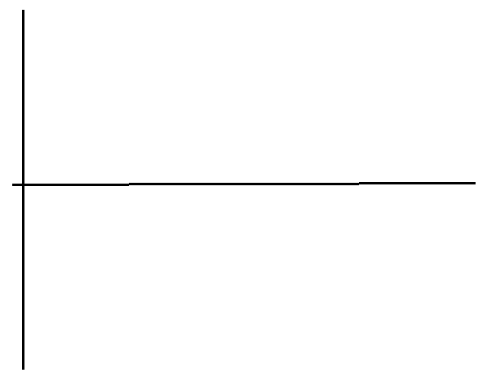

## For how long was the walker stationery? (1 mark)